**What is Maven?**

It is product of Apache. All the open source communities like Jenkins, tomcat, mysql etc upload their updated API's into maven global server ( search.maven.org )

**What is maven global server?**

Developers connect to the maven global server, download those API that are necessary for the project development and store them in Maven local repository.

**What is Maven local repository?**

All developers connect to maven local repository and perform the development activity.

In this way, the code is stored separately in GitHub and API's required for code development are stored in maven local repository.

This will help in protecting the code from any threats/viruses that might be present in the API's.

Maven is also a build tool. Where it can compile the programs and create a artifact.

+++++++++++++++++++++++++++++

**Configure Maven**

In google -- jdk 1.8 download

Download and Install

**Where jdk is installed?**

C:\Program Files\Java\jdk-11.0.15

Copy the path of jdk

This PC --> properties -- Advanced system settings --> advanced tab---> Environment variables --> system variables – new

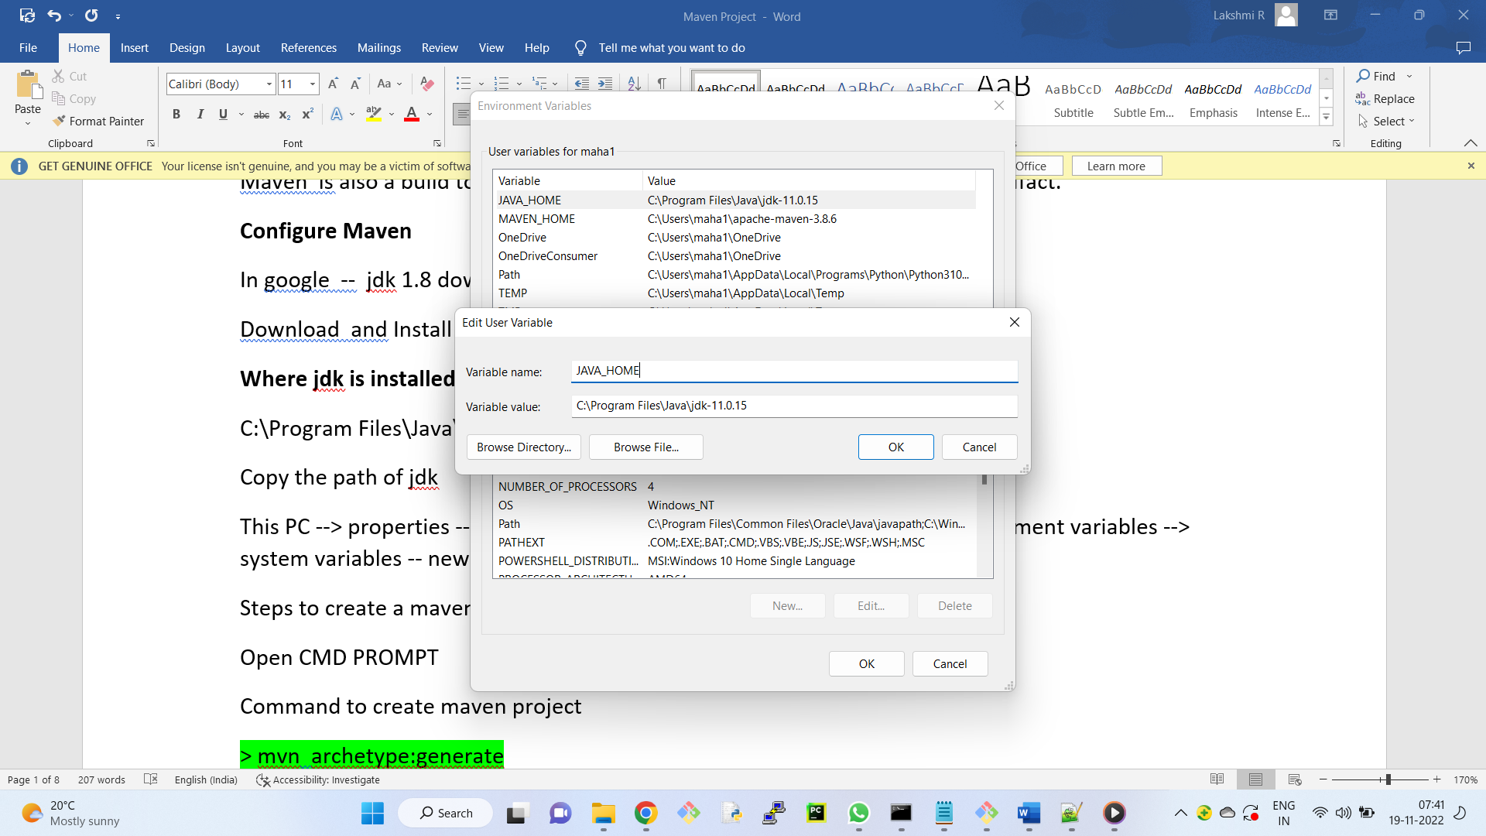

Variable name - JAVA_HOME

Variable value - C:\Program Files\Java\jdk-11.0.15

Ok

Now, go to "path" variable --- Edit -- click on new button

C:\Program Files\Java\jdk11.0.15\bin

Ok

++++++++++++

Download apache Maven

In files section

download bin.zip version and extract

++++++++++++++++++

Again, create new environment variable

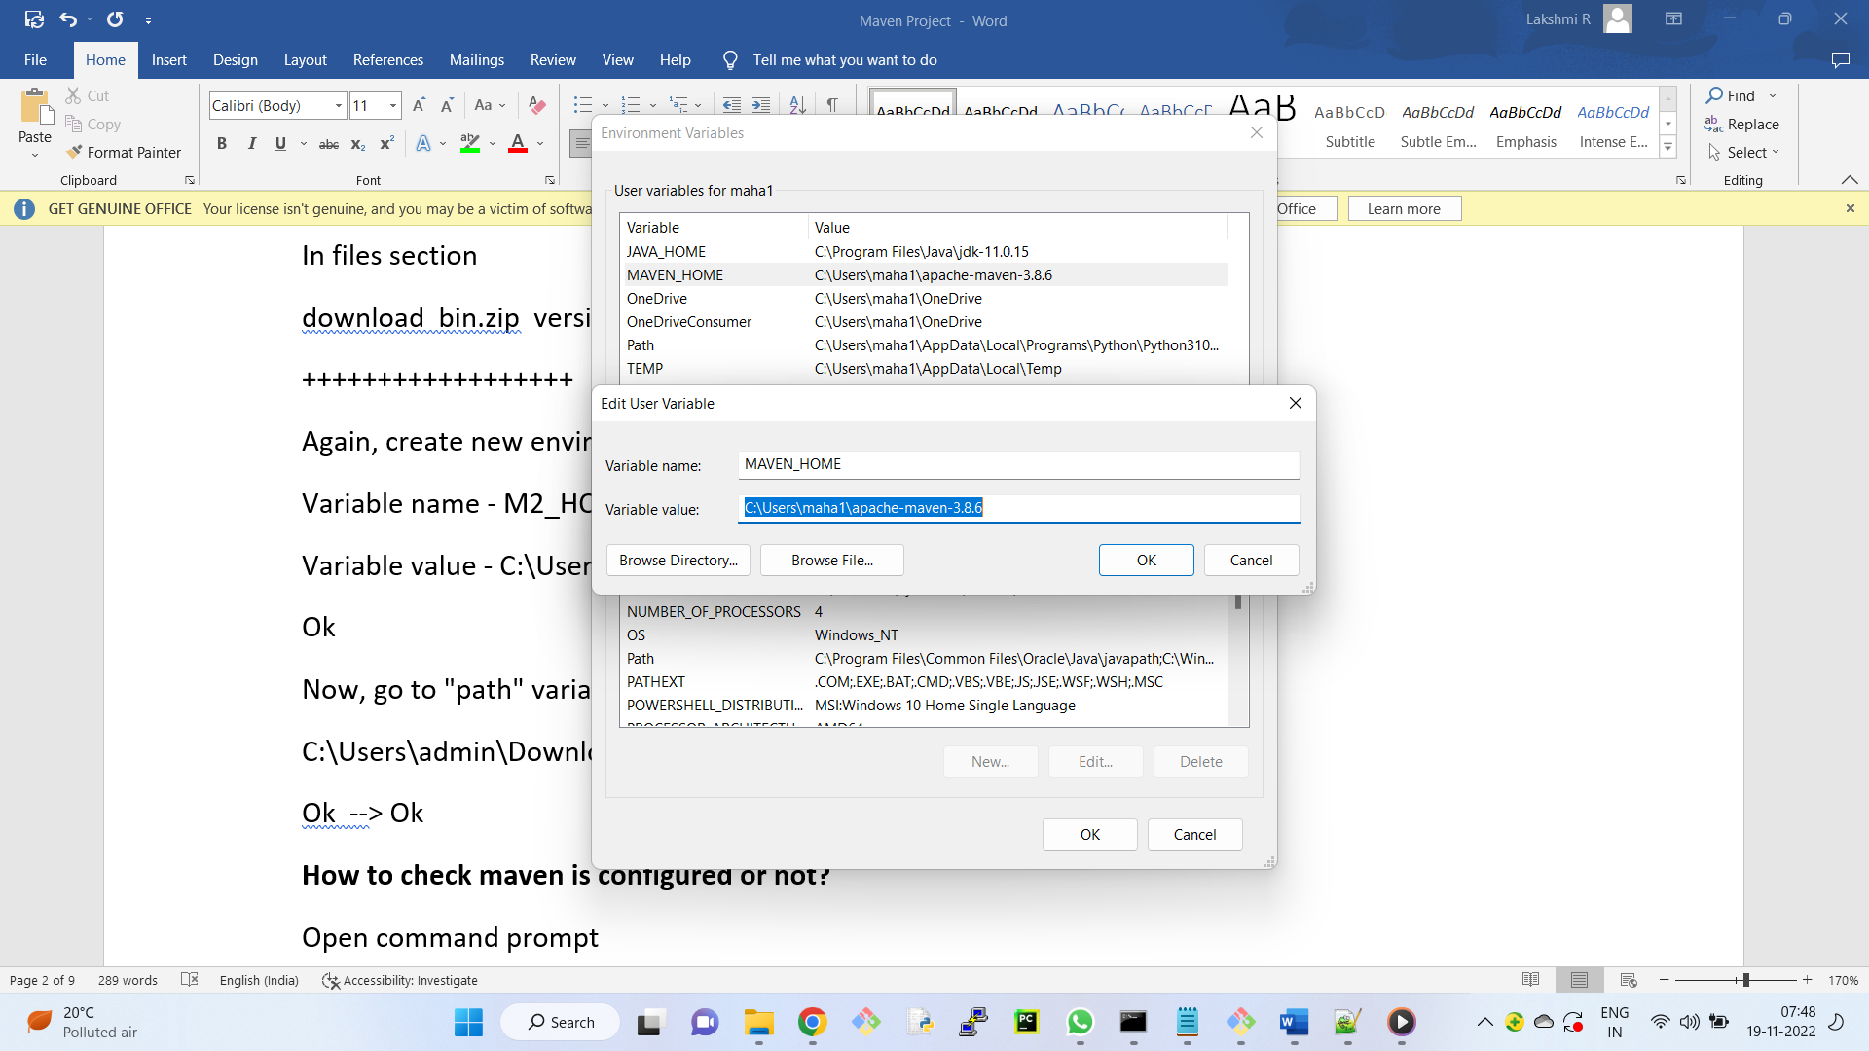

Variable name - MAVEN_HOME

Variable value - C:\Users\maha1\apache-maven-3.8.6

Ok

Now, go to "path" variable --- Edit -- click on new button

C:\Users\admin\Downloads\apache-maven-3.8.6\bin

Ok --> Ok

**How to check maven is configured or not?**

Open command prompt

> mvn --version

++++++++++++++

For any GitHub related queries

**GitHub Error**

<https://www.programmersought.com/article/10284558358/>

**What is an artifact?**

**What is maven number?**

**What is groupid ( is noting but project structure )**

Steps to create a maven project

Open CMD PROMPT

Command to create maven project

> mvn archetype:generate

Choose a number or apply filter:

Note: Type of the project is dependent on the above number

1740 -- For Spring project

1765 -- For sample maven project

1244 -- MVC 4 Web application

2630 -- Project for multiple platforms web, Android and iOS

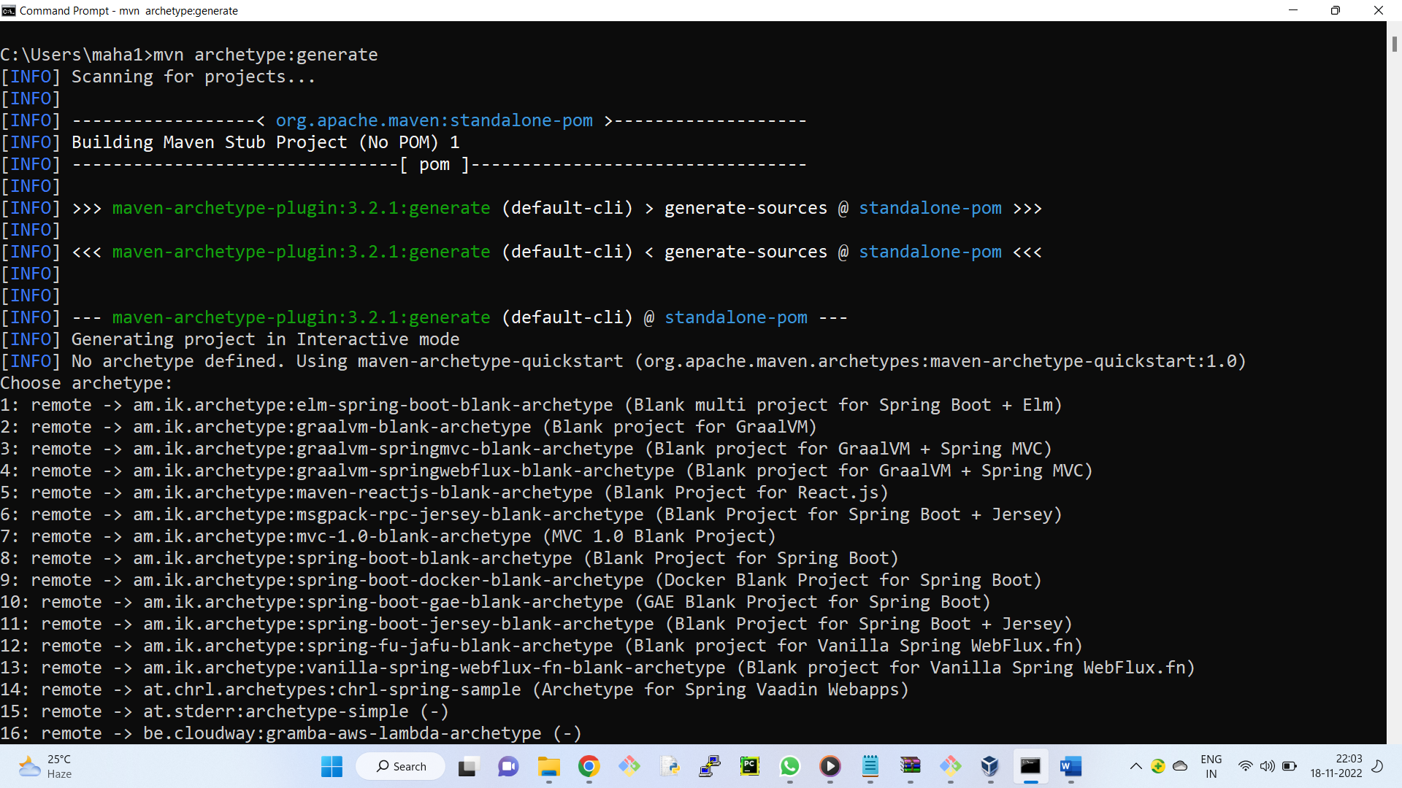

Lets select the default number: 1990 (Sample maven project)

ENter default number - It will take time

Now, we need to choose the version. Lets take the default one 8.

Now, Define value for group id. What is groupid?

Is used to follow a project structure. ex: For commercial application -- Ex: com.<project_name>

For government application -- Ex: gov.<project_name>

For organization application -- Ex: org.<project_name>

Define the value for groupID: com.flipkart

What is Artifactid: webappflipkart ( With this name artifcat will be created )

We get BUILD SUCCESS message

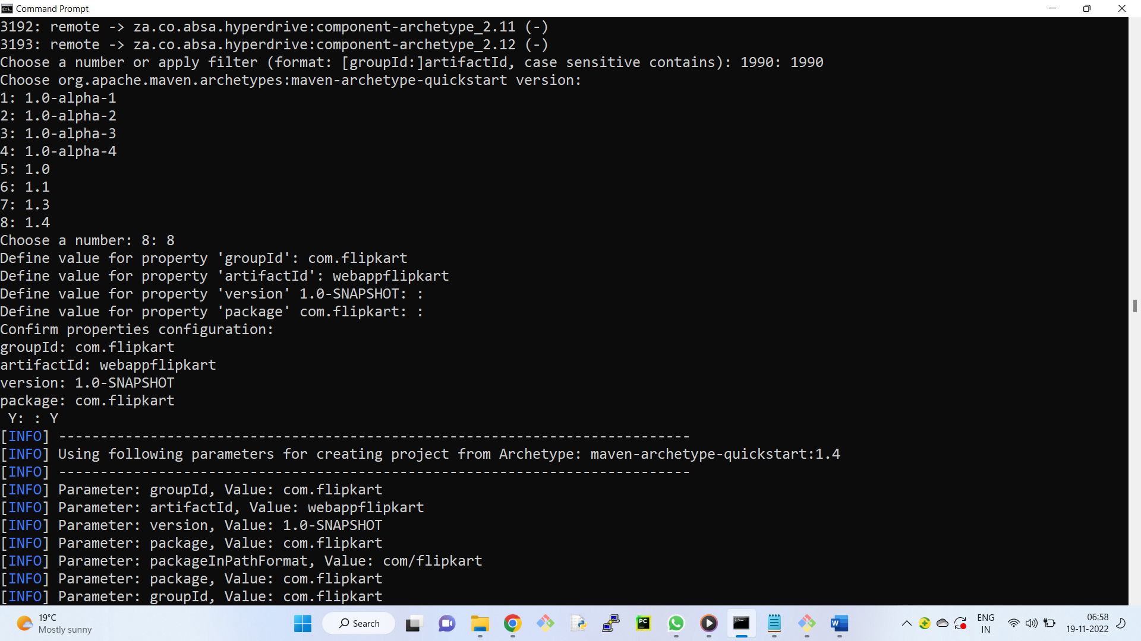

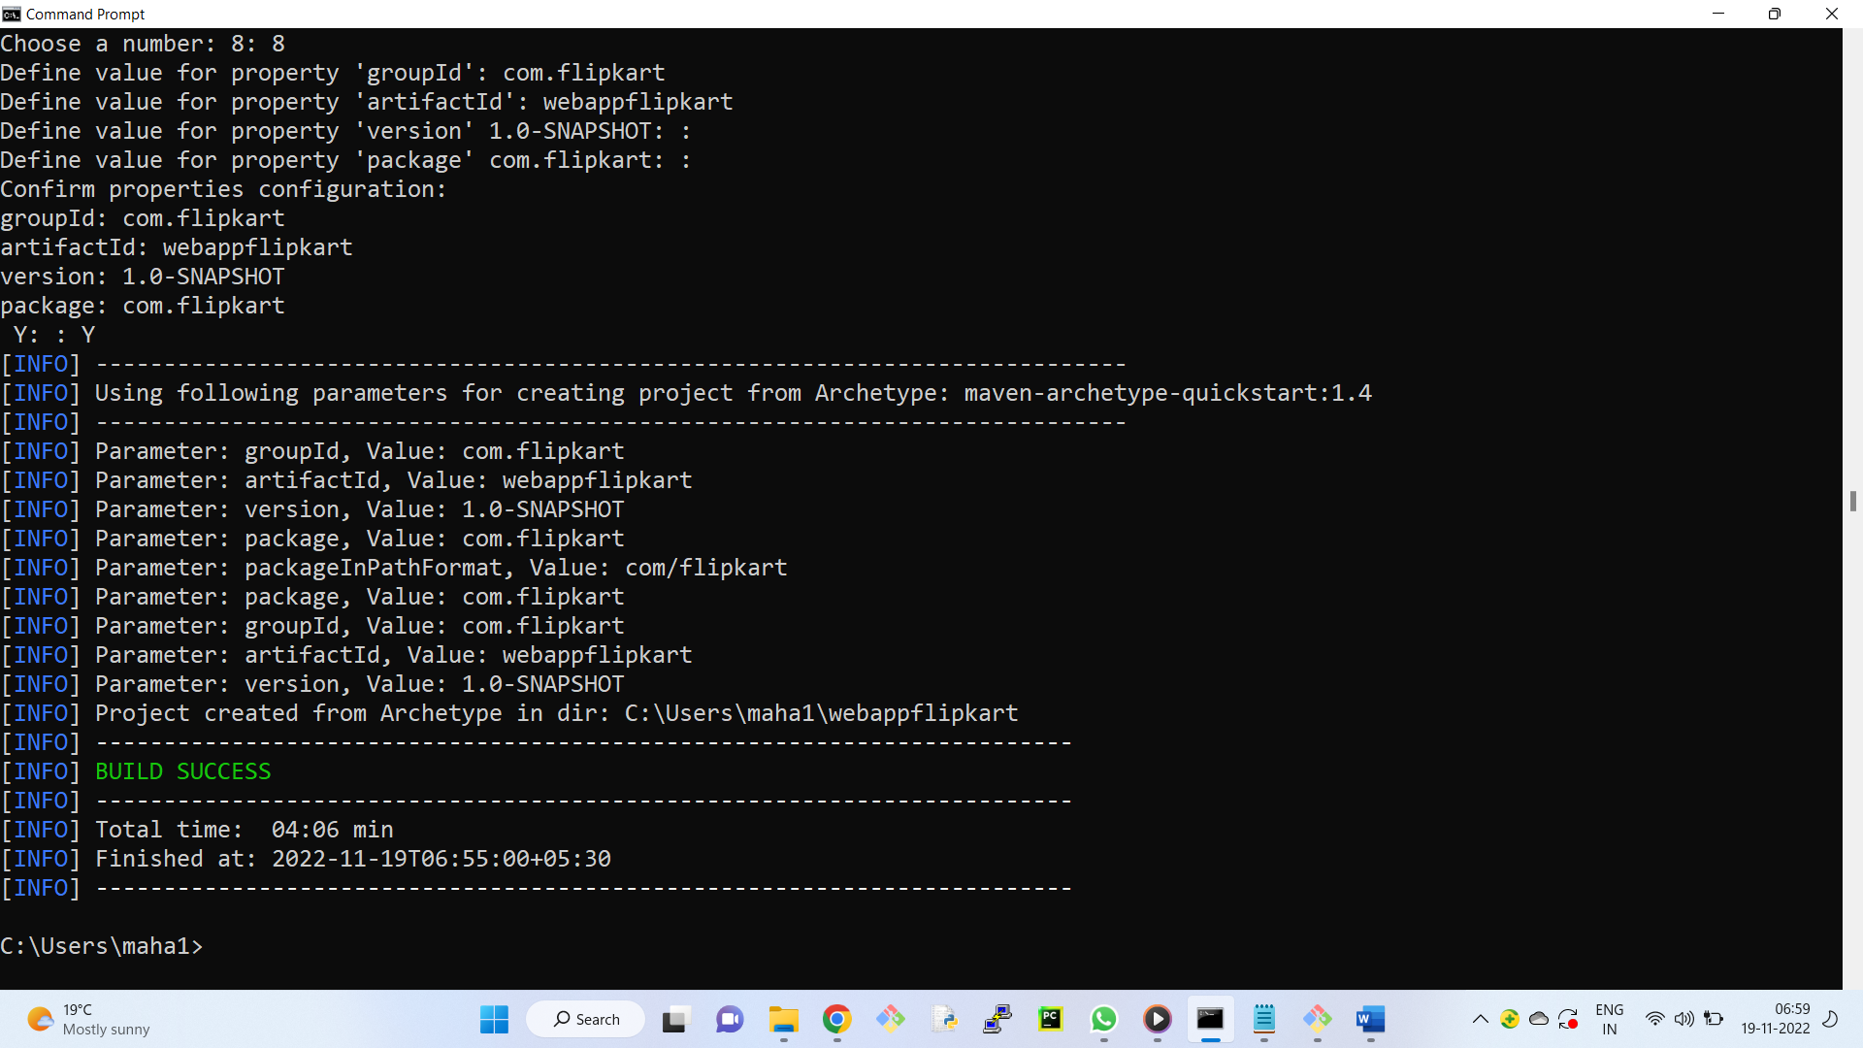

In which location project is created?

C:\Users\maha1\webappflipkart

In that location, we find src folder and pom.xml file

src contains two folders.

main and test

Code created by the developer will be in main folder.

Code created by the developer for unit testing will be in test folder.

**POM -- stands for project Object model.**

It is an xml file, which will store all the external API information.

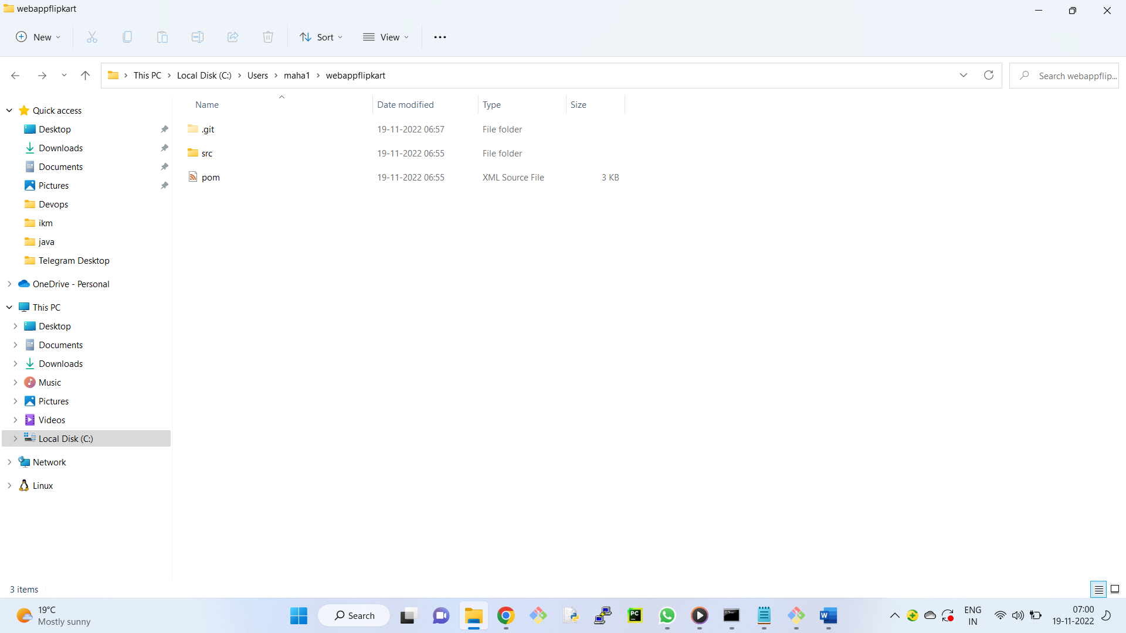

+++++++++++++++++++++

Open **GitBash**

change directory to webapppaypal

$ git init

$ git status

$ git add .

$ git commit -m "first commit"

+++++++++++++++++++++

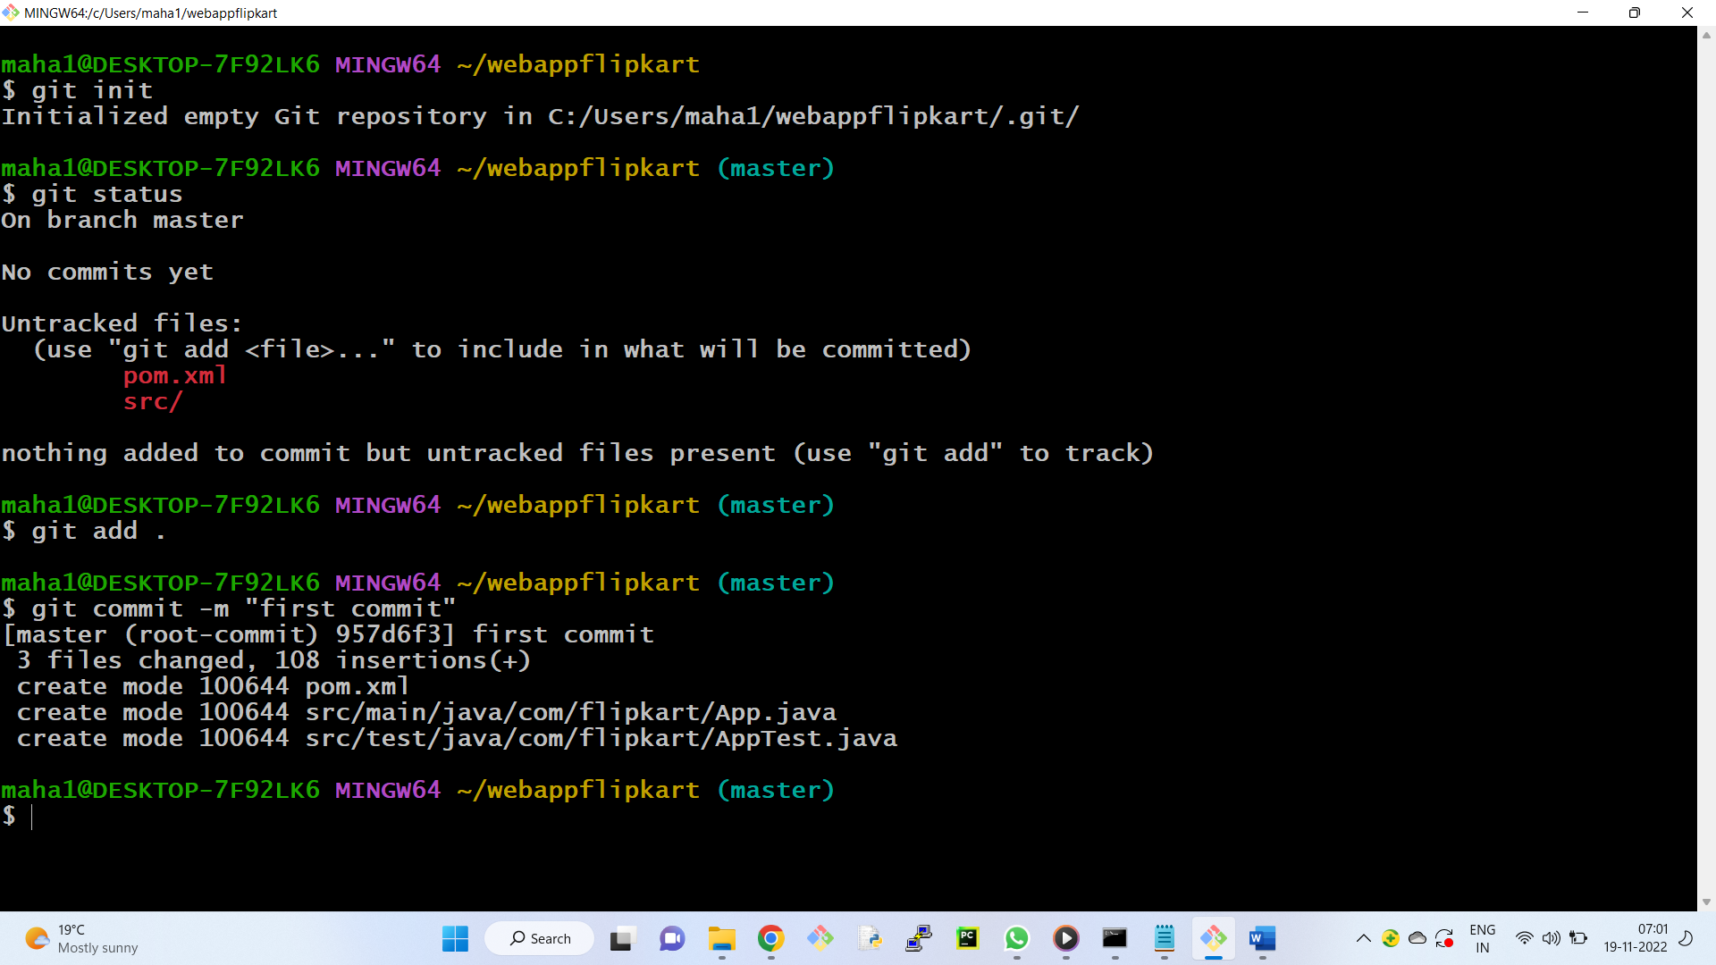

**https://search.maven.org/** -- maven global server

Developer will search for the required API here

Ex:

1) search for mysql ( select the required API ) - select version

copy the dependency tag and paste in pom.xml

2) search for google map

copy the dependency tag and paste in pom.xml

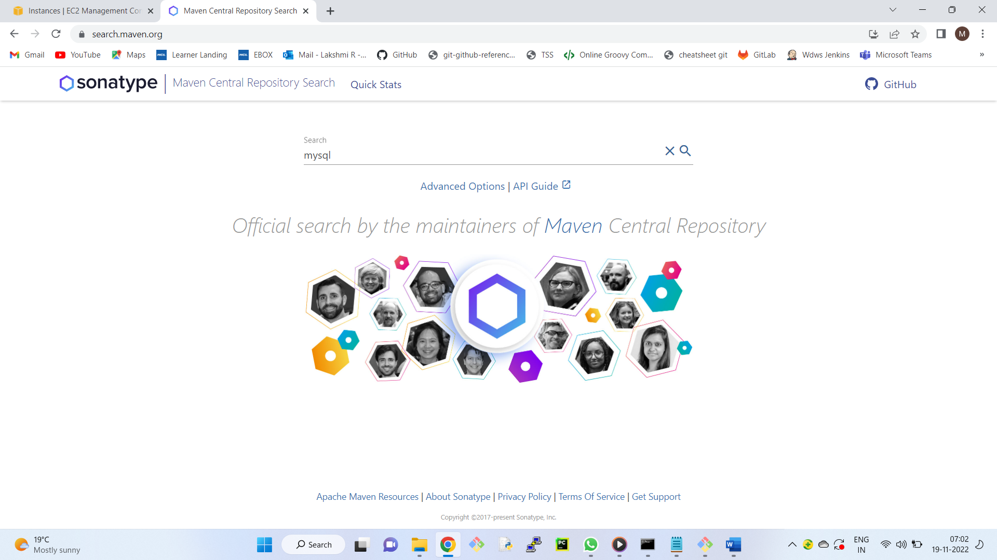

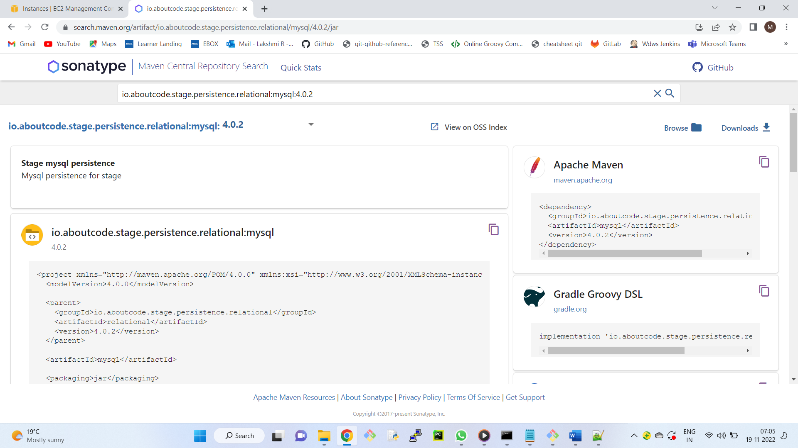

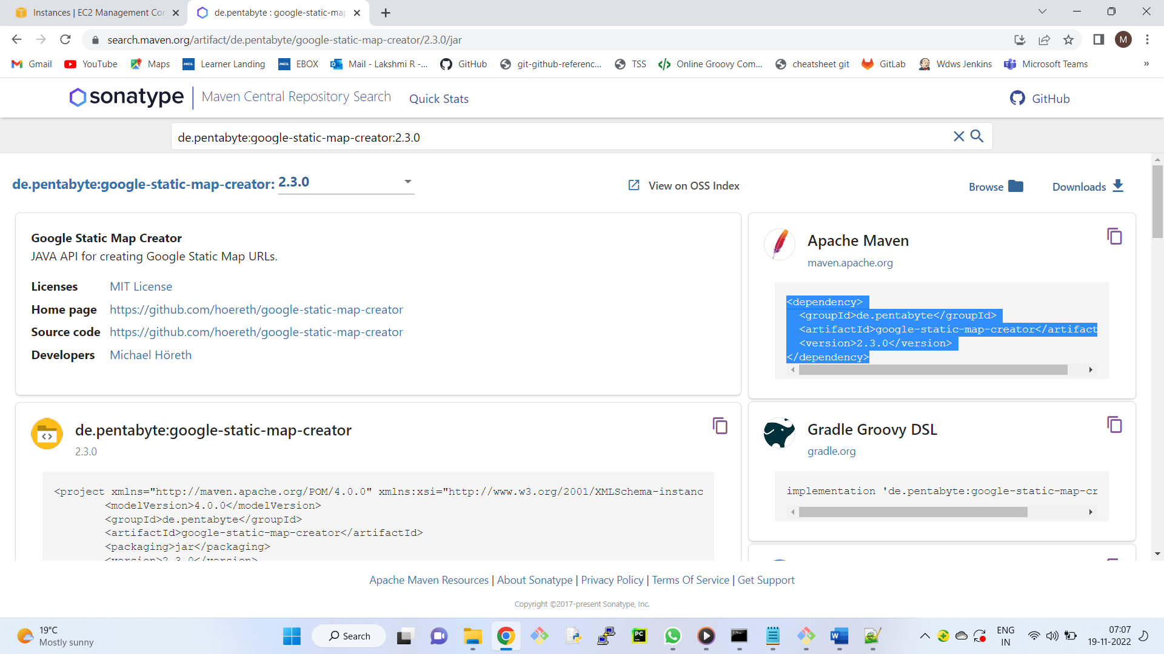

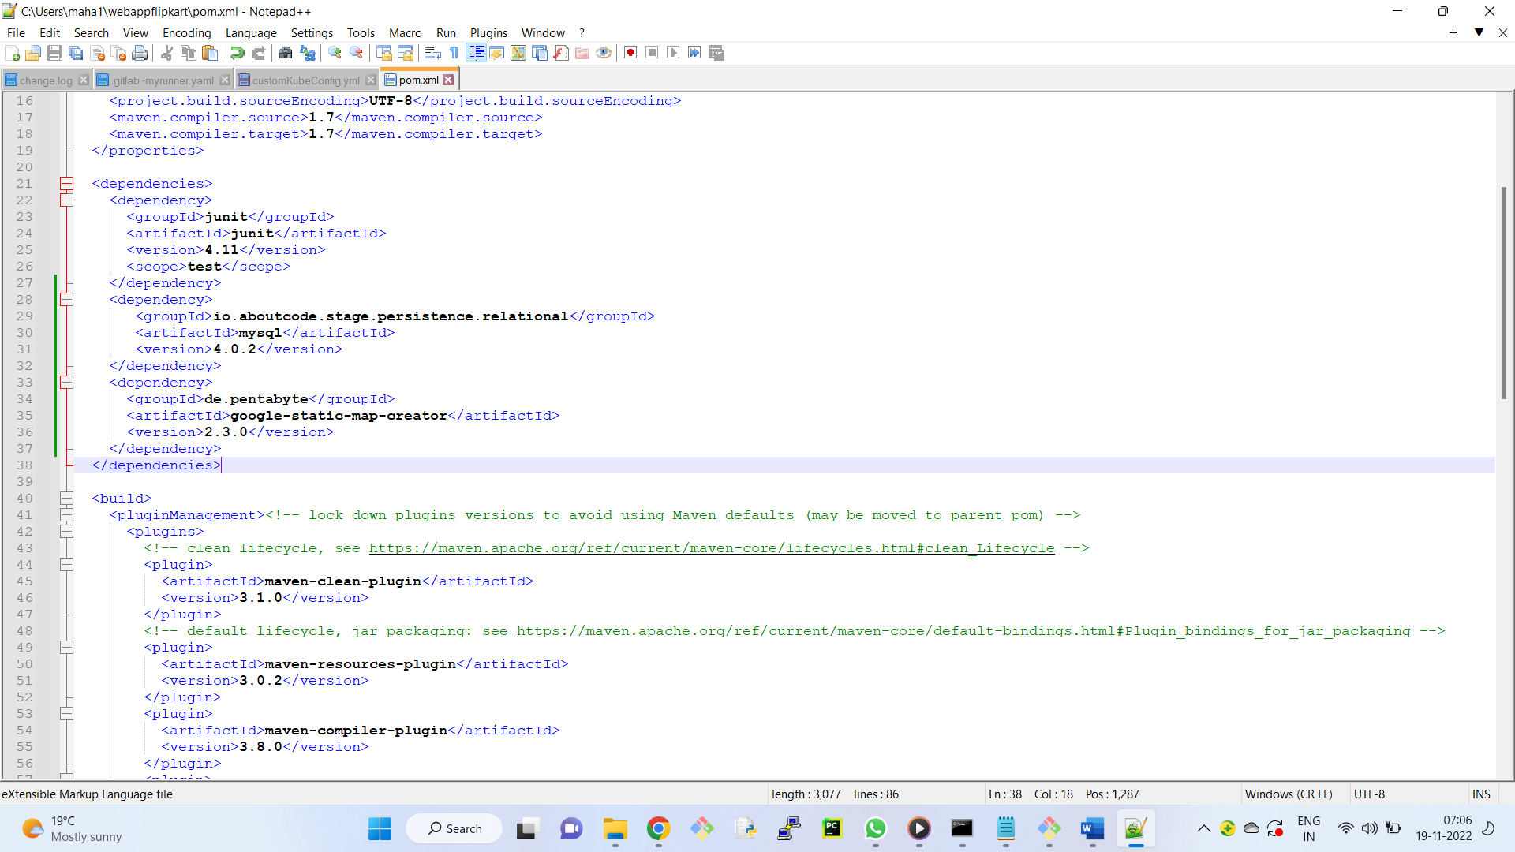

Now, we need to download the API from Maven Global server to Maven local repository.

Open command prompt

> cd webappflipkart

> mvn compile

Maven local repository is created with the name .m2

+++++++++++

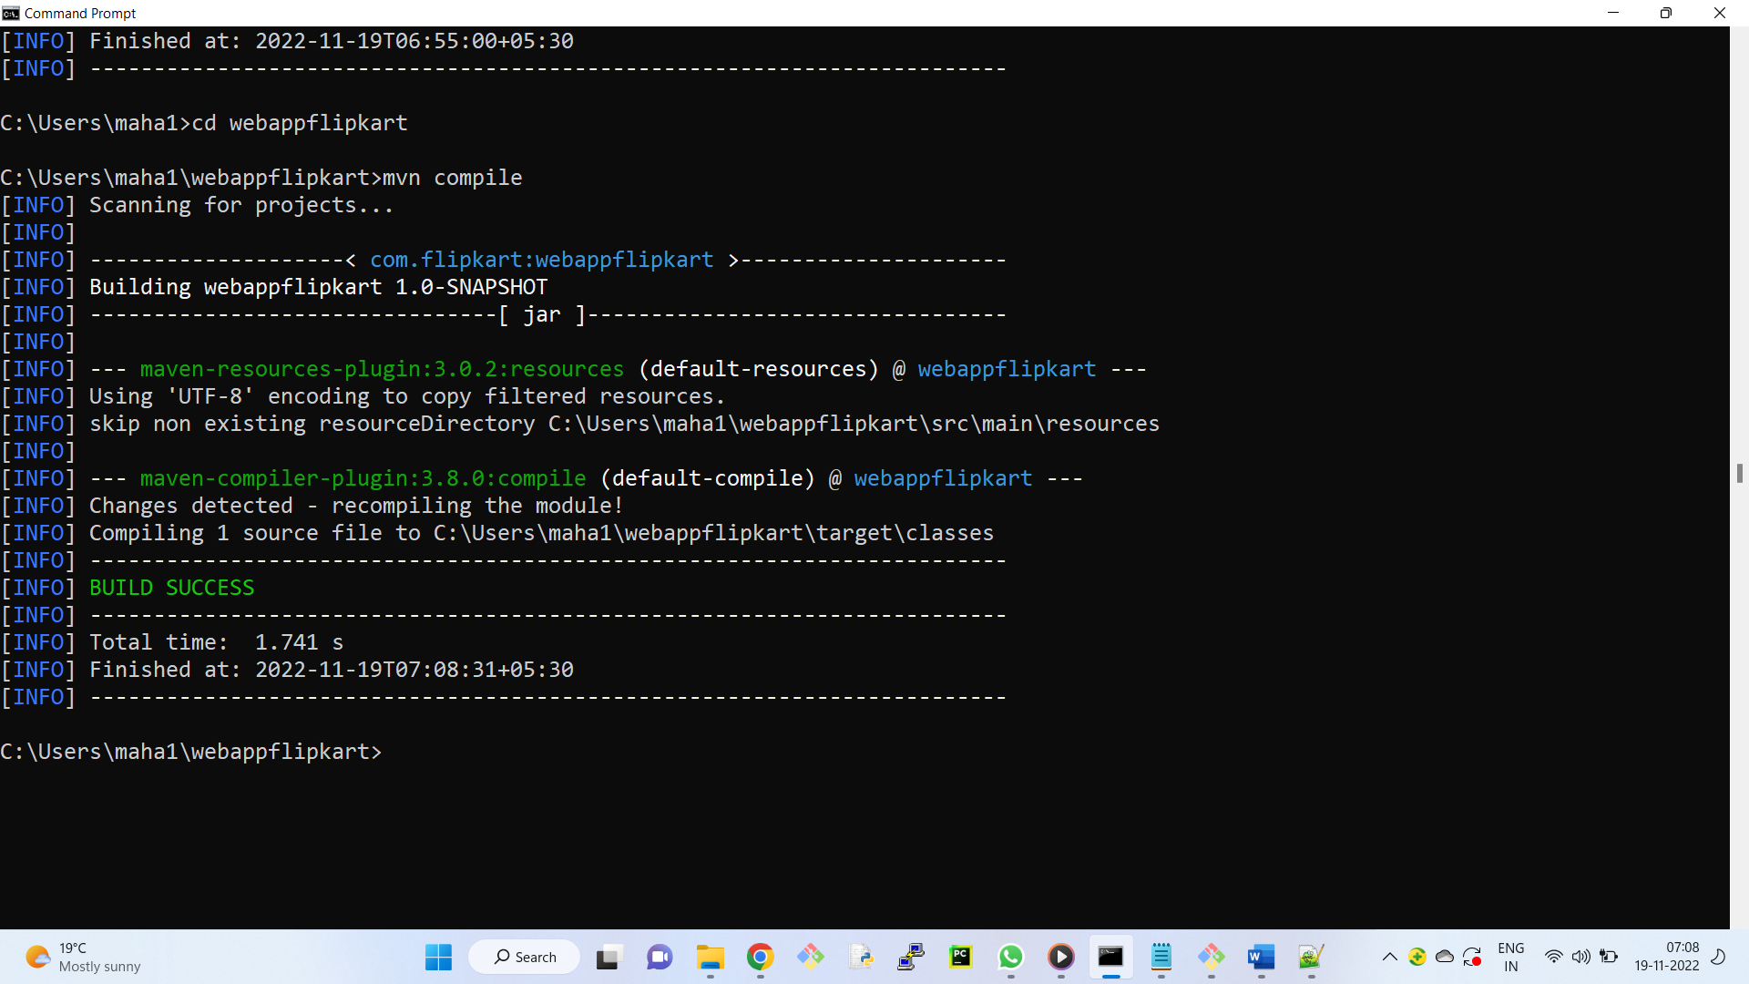

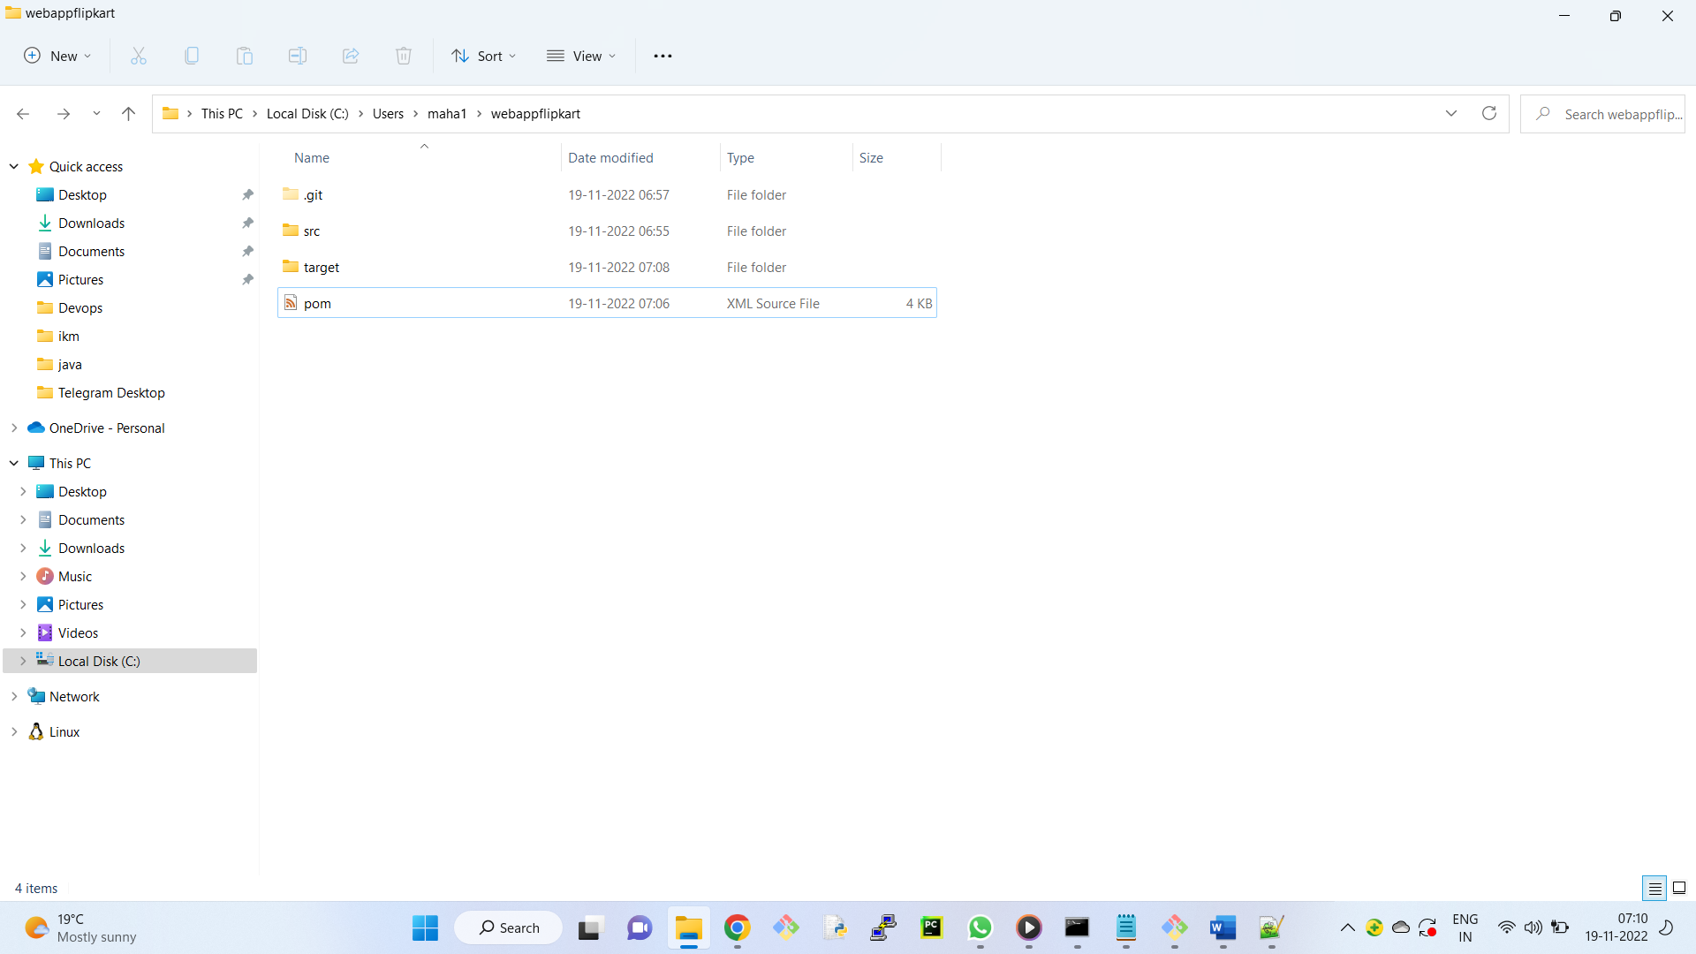

Open git bash

Go to working directory

$ git status

$ git add .

$ git commit -m "second commit"

++++++++++++++

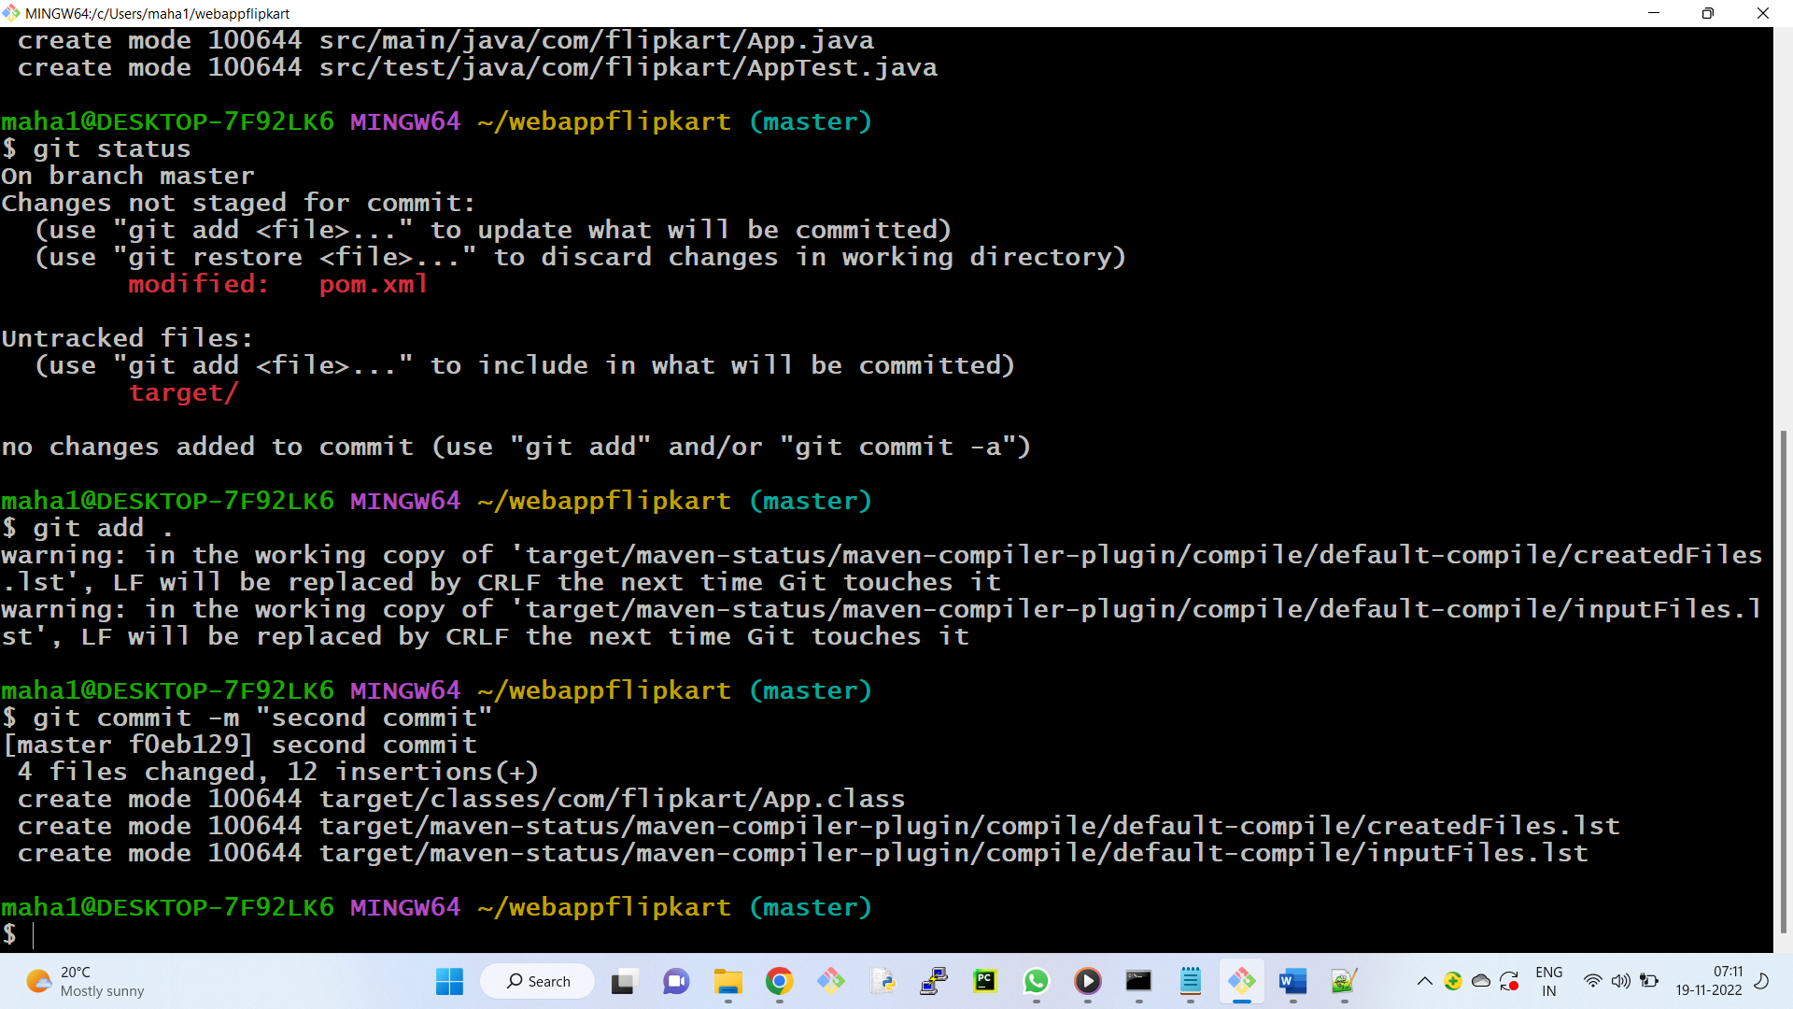

Notes: Adding 3rd party API to pom.xml file.

Observe the folder structure created in the maven project ( webappflipkart )

We can find the folder structure as mentioned in "groupid"

They have given sample java Project.

Copy code in App.java, lets create a new java file, save as Sample.java ( change class name also)

code

---------

package com.flipkart;

/**

* Hello world!

*

*/

public class Sample

{

public static void main( String[] args )

{

System.out.println( "Hello World" );

}

}

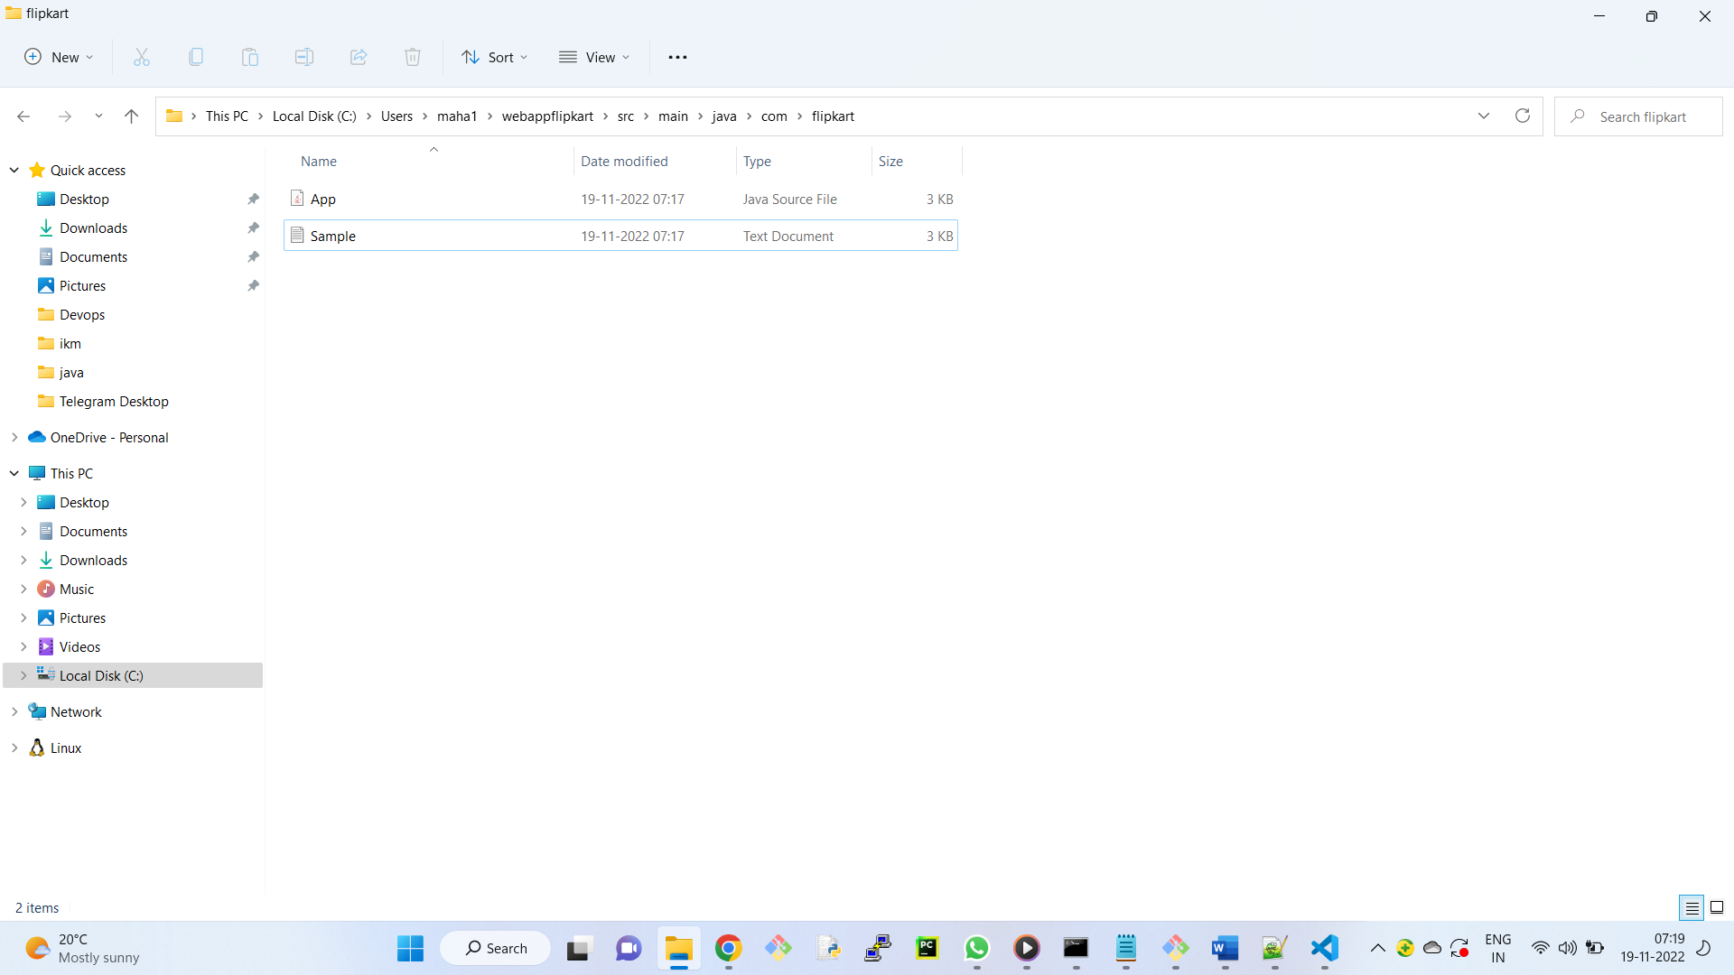

Now, we need to compile the java files . In command prompt

> mvn compile

Observation:

A new folder target is created in webappdurga, we can see the class files.

Similarly

goto src/test/java/com/flipkart

create another java file with the name SampleTest.java

Add one line of code at the end ( for our reference )

System.out.println("Testing Passed");

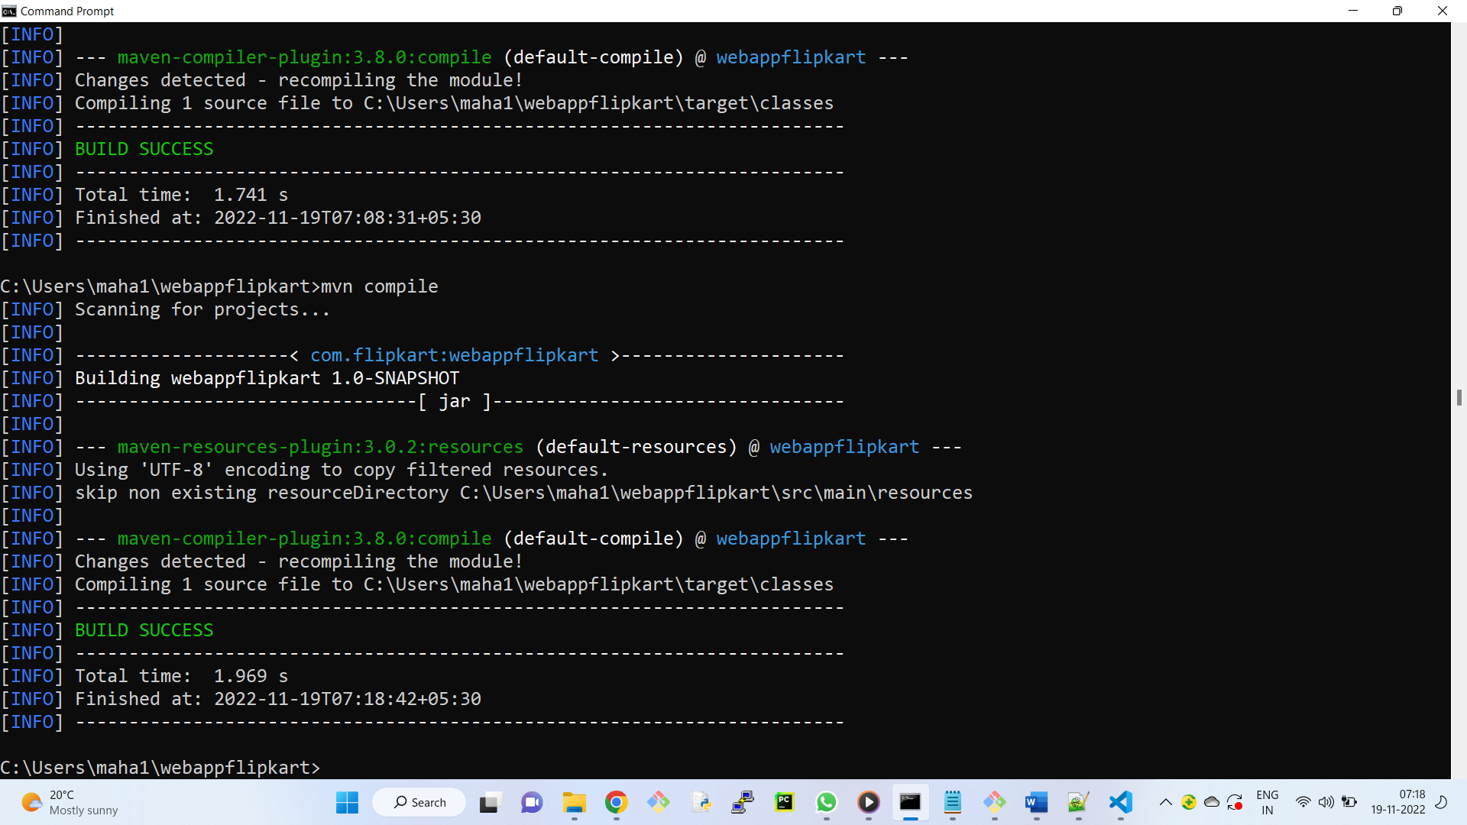

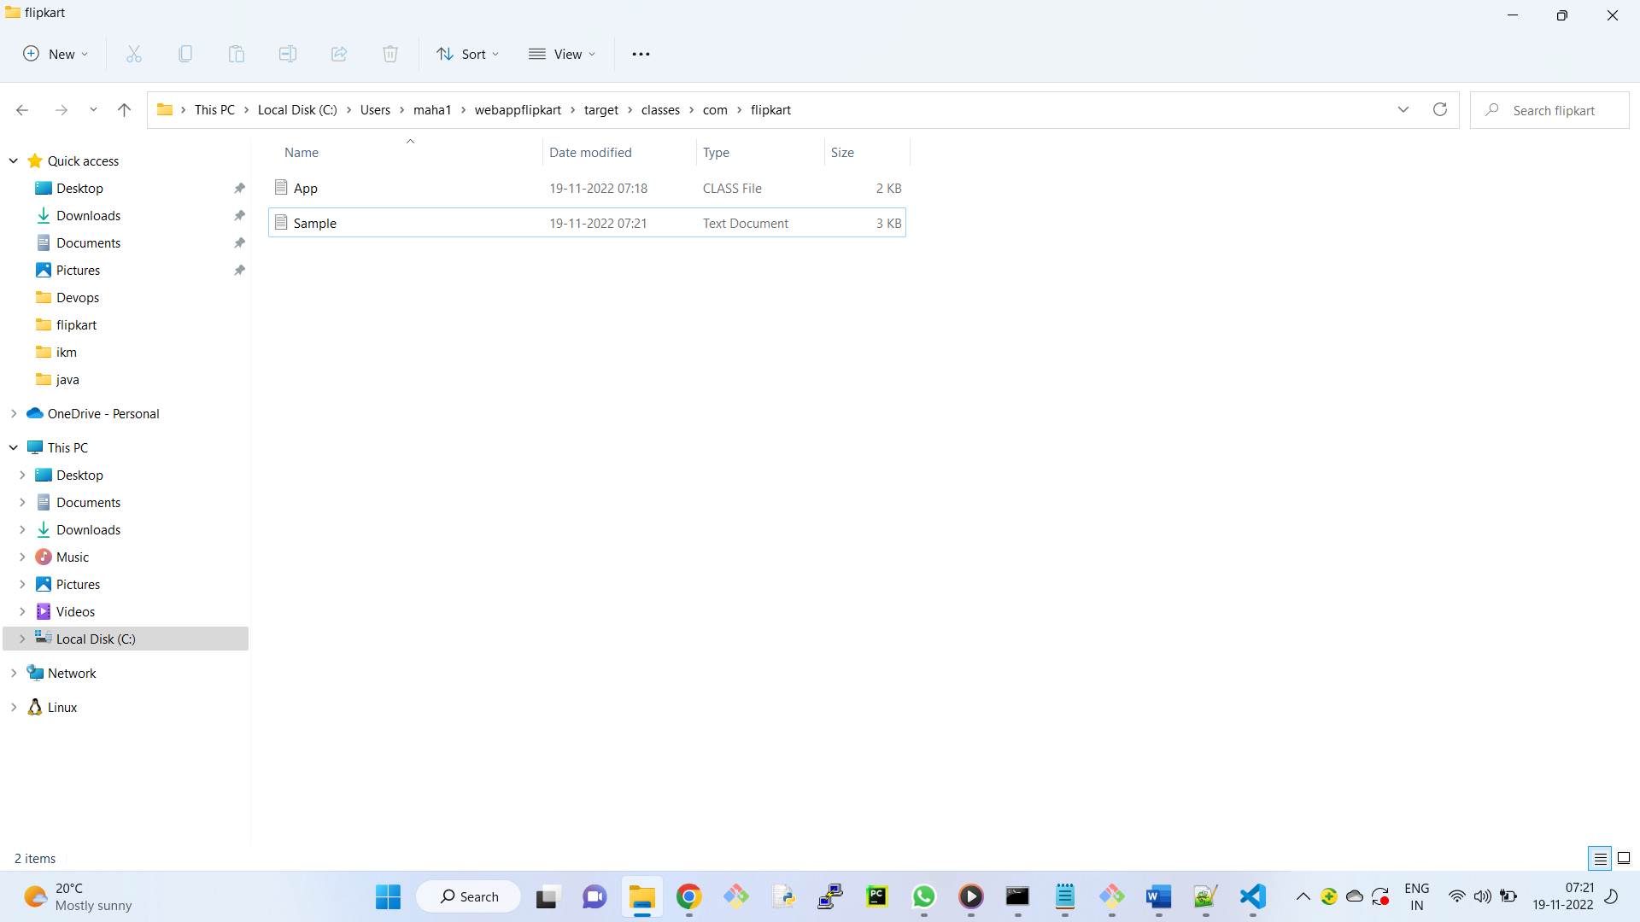

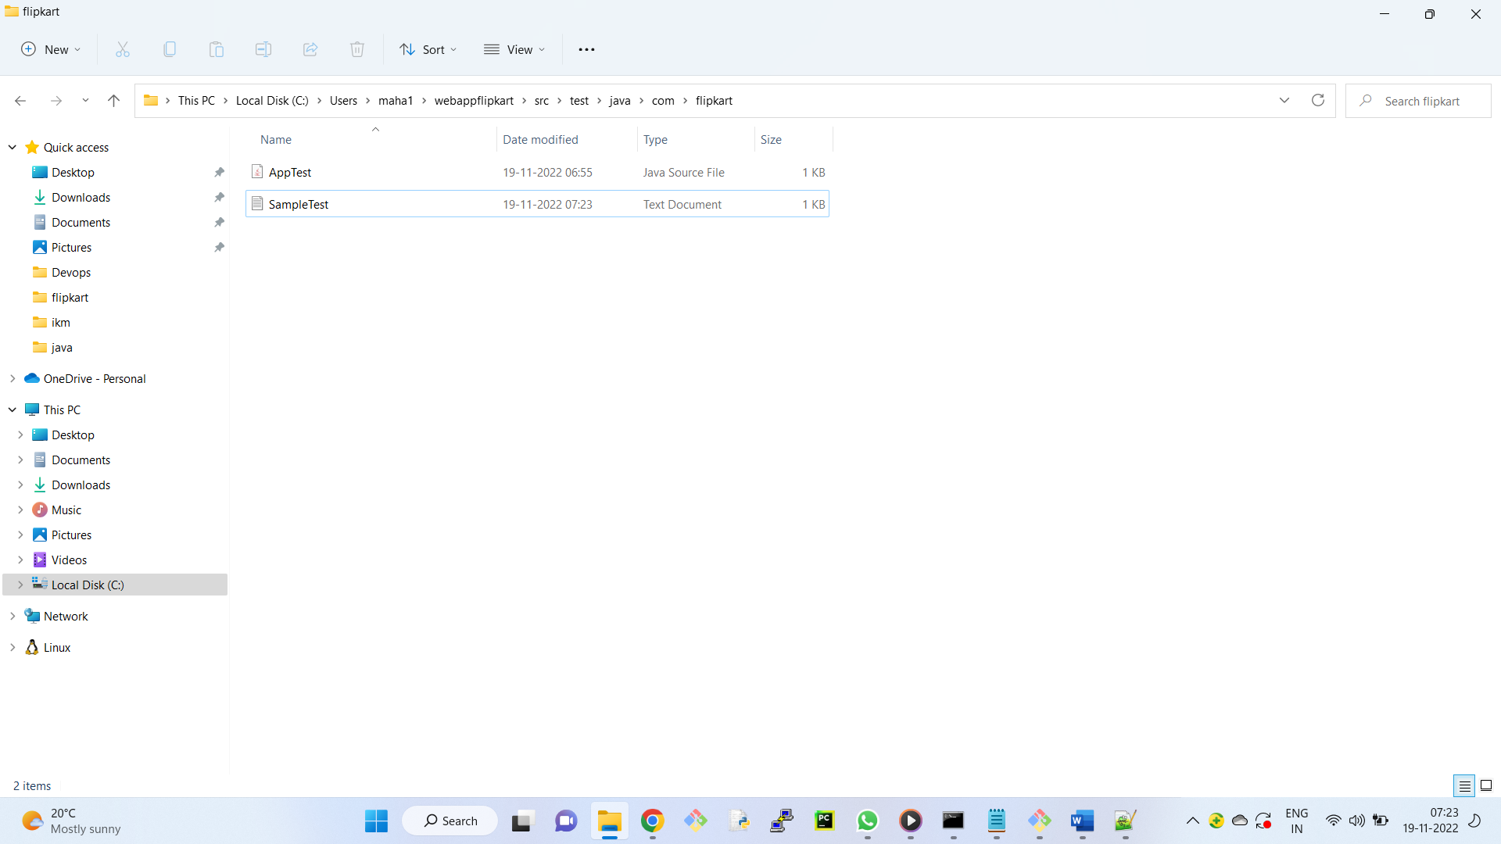

Now, we need to convert the unit testing code into .class file, for that we have command

> mvn test

Observation:

In folder target , test-classes will be created , which contains .class files

To create Artifact

> mvn package

Where is the location of the artifact?

C:\Users\maha1\webappflipkart\target\

Webappflipkart-1.0-SNAPSHOT

